SELECT with various clause – GROUP BY, HAVING, ORDER BY
AIM:
To view the records from the tables using SELECT commands with Group By, Having, Order By

DESCRIPTION:
GROUP BY – HAVING:
➢ The GROUP BY clause groups a set of rows into a set of summary rows by values of columns or expressions. The GROUP BY returns one row for each group. In other words, it reduces the number of rows in the result set.
➢ The GROUP BY clause is used with aggregate functions such as SUM, AVG, MAX, MIN, and COUNT. The aggregate function that appears in the SELECT clause provides the information about each group.
➢ The GROUP BY clause is an optional clause of the SELECT statement.
➢ To filter the groups returned by GROUP BY clause, you use a HAVING clause.

PART A — GROUP BY AND HAVING
QUESTION 1
Count how many customers purchased each type of juice.
Run:
SELECT juice_name, COUNT(*) AS customer_count
FROM juiceshopc
GROUP BY juice_name;
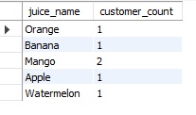
QUESTION 2
Find the total number of juices purchased for each juice type.
Run:
SELECT juice_name, SUM(no_of_juices) AS total_juices
FROM juiceshopc
GROUP BY juice_name;
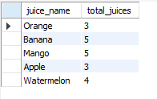

QUESTION 3 — HAVING
Display only the juice types whose total number of juices purchased is greater than 3.
Run:
SELECT juice_name, SUM(no_of_juices) AS total_juices
FROM juiceshopc
GROUP BY juice_name
HAVING SUM(no_of_juices) > 3;
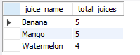

PART B — ORDER BY
QUESTION 4
Display all customers in ascending order of token number.
Run:
SELECT customer_name, token_no, juice_name
FROM juiceshopc
ORDER BY token_no ASC;

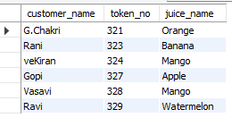

QUESTION 5
Display customers in descending order of number of juices purchased.
Run:
SELECT customer_name, juice_name, no_of_juices
FROM juiceshopc
ORDER BY no_of_juices DESC;
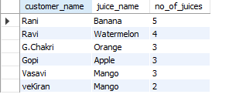

QUESTION 7
Display only payment modes having more than 2 customers.
Run:
SELECT payment_mode, COUNT(*) AS customer_count
FROM juiceshopc
GROUP BY payment_mode
HAVING COUNT(*) > 2;

RESULT
The records from the juiceshopc table were successfully displayed and analyzed using the GROUP BY, HAVING, and ORDER BY clauses.

